

**2ND SEMESTER 2021/2022 ACADEMIC YEAR**

**END OF SEMESTER EXAMINATION ANSWER BOOKLET**

THE FOLLOWING DETAILS MUST BE COMPLETED BY THE STUDENT

400

ADS19A00110Y

STUDENT’S ID NUMBER­­­­­­­­­­: _______________________________ LEVEL: __________

CS456

Advanced System Analysis and design

COURSE COD**E: _________** COURSE TITLE: _________________________________

FERDINAND HIAGBE

LECTURER’S NAME: (Refer to the Question Paper) ________________________________

**QUESTION NUMBER: (e.g., Q1) ___1___SUB-QUESTION (e.g., 1(a)) _1A, B, C_**

1. As the head system analyst, I will adopt to the **Agile Method** because with this method Time and cost are two main restrictions that can be regularly assessed. Teams' plans are designed to incorporate quick feedback, ongoing modification, and best practices for Q&A, resulting in high-quality production and an efficient workflow. It focuses on delivering features with the highest business value first, followed by communicating real-time information to enable strict management of the project's cost, time, and scope. Systems analysis & design can also help schools get more output out of our resources, help schools achieve goals, assist in making decisions that move a system closer to its purpose, provision of a benchmark to compare options, help schools justify spending, and enhance public relations. System analysis has a wide range of advantages, but it may also have significant drawbacks. The danger of conducting excessive analysis, which may be expensive and time-consuming, is one of the key drawbacks that is frequently disregarded. Finding the ideal balance is consequently a necessary aspect of the analyst's job.

Despite everything Agile can do, not everyone will want to use it. It's crucial to understand the drawbacks of the Agile technique as a result. Here are few drawbacks of Agile;

More dedication and time: Although collaboration and communication are fantastic, the ongoing interaction requires more time and effort from all parties.

Greater demands on clients and developers: Agile Method can only be successful with everyone's commitment. A project's quality can suffer from anyone who isn't on board.

Lack of the required documentation: Under the Agile Method, tasks are frequently finished right before development begins, which causes less extensive documentation, which might cause misunderstandings and problems in the future.

Projects frequently fall off course: Due to the Agile Method's lack of structure, projects can rapidly get off track or exceed their original scope.

1. Relevant information methods to be used;

Questionnaire: As they are significantly more casual, questionnaires are effective methods for gathering needs from faraway stakeholders or those who will only have a little impact on the overall set of requirements. When you need to get the opinions of dozens, hundreds, or thousands of people, questionnaires can also be used. A questionnaire is a type of research tool or instrument that consists of a number of closed- or open-ended questions. The objective is to gather pertinent information from responders that can be applied to various scenarios. Giving the respondent the option to provide a longer response allows them to build on their ideas, which can lead to more insightful responses. For instance, a business can seek for comments on a recent customer service encounter, while psychology researchers might use surveys to look into people's perceptions of health risk.

Questionnaires are helpful for getting details from important stakeholders in an organization about:

* Attitudes – what members of an organization claim to want.
* Beliefs – what people genuinely believe to be true.
* Behavior – what individuals in an organization do.
* Characteristics – the qualities of individuals or things.

Interviewing in Information Gathering: You must in fact interview yourself before you interview anyone else. You must be aware of your biases and how they may skew your judgment. For the information you will hear in your interviews, your education, intellect, upbringing, emotions, and ethical framework all operate as effective filters.

Prior to the interview, you must give it careful thought. Think about your motivation for attending, the questions you'll ask, and what, in your opinion, will make the interview successful. You must plan ahead on how to make the interview enjoyable for the interviewee as well. A question-and-answer formatted dialogue with a specified goal is known as an information-gathering interview. You want to learn the interviewee's ideas and feelings about the system's current status, his or her personal and professional aspirations, and informal protocols for engaging with information technologies.

Above all, ask the individual you are interviewing for their opinions. Facts may not be as significant or illuminating as opinions. For instance, consider questioning the proprietor of a brick-and-mortar company who has recently added an online store about the number of refunds she regularly provides to customers for online transactions each week. "About 20 to 25 a week," she responds. When you keep track of the transactions and see that the typical amount is only 10.5, You can draw the conclusion that the owner is exaggerating the situation. In-depth interviews are a great way to learn about goals. Hard data facts may be able to explain previous success, but goals look to the future of the firm. Interviewing should be used to learn as many of the organization's objectives as you can. Goals might not be discernible with any other data collection techniques. The interview is a great opportunity to discuss important HCI (human-computer interaction) issues, such as ergonomics, system usability, how appealing and fun the system is, and how effective it is at assisting with specific tasks. You are establishing a relationship with a potential stranger during the interview. While establishing trust and understanding rapidly, you also need to keep sway over the interview. Additionally, you must persuade the interviewee to buy the system by giving them the essential details. Do this by preparing for the interview in advance so that you can conduct it naturally.

1. The three qualities that I must possess are;

Communicator: The analyst needs to be proficient in both speaking and presenting. He needs to be a master of the language that the user can grasp. The systems analyst and users should be able to communicate with each other without any problems.

Problem solver: The analyst should be exceptionally creative in order to translate user ideas into workable proposals. He or she should be able to create systems and make plans by developing diagrams, charts, and other illustrations. By examining the current system, the analyst must be able to identify the users' actual difficulties. He is anticipated to offer the greatest answers to the issues. In order for the customers to choose the best solution, he should be able to offer more than one to a single issue. Any user issue must be able to be solved by the systems analyst. He needs to be a problem-solver rather than a problem-maker.

Self-disciplined and self-motivated: The systems analyst must be a self-disciplined, self-driven person with the ability to manage and organize several project resources in addition to other people.

**QUESTION NUMBER: (e.g., Q2) _2_SUB-QUESTION (e.g., 2(a)) _2A, B, C_**

1. TWO approaches that will be useful in your arrangement of questions;

CLOSED – ENDED QUESTIONS:

Closed-ended questions give respondents a predetermined range of options to choose from. For gathering information on category or quantitative factors, closed-ended questions work well.

* Use when all the options may be listed
* When the options are mutually exclusive

Closed-ended questions with a good design are simple to understand and quick to respond to. You could still, however, overlook vital information that is pertinent to the responses. Some respondents can be forced to select the option that comes the closest to their actual reaction if the response options are insufficient. Additionally, many queries could exclude crucial information. You can circumvent these issues by making certain questions partially closed-ended and including an open-ended that allows responders to provide their own response.

OPEN – ENDED QUESTIONS:

Open-ended let respondents react in their own words.

* Try to anticipate the response you will get
* Well suited for getting opinions

Respondents are able to provide answers that researchers may not have otherwise thought of because there are no limitations on their options. For a race question, for instance, respondents might choose to choose "multiracial" over something from a limited choice. For instance, of open-ended;

* What are your thoughts on open science?
* What would you say about yourself?
* What do you think is the main barrier to productivity in remote work?

They demand more from respondents in terms of time and effort, which may discourage them from responding to the survey.

1. The three potential benefits are;

* Rapid development of systems:
* Improved user ownership of the system
* Creative idea production is improved

1. The drawbacks are;

* J A D needs a big block of time to be available for everyone in the session.
* The meeting might not go well if preparation or the follow-up report are lacking.
* The organizational culture and capabilities might not be favorable for a J A D session.

**QUESTION NUMBER: (e.g., Q2) _4_SUB-QUESTION (e.g., 2(a)) _4A, B, C_**

1. Errors found in the diagram;

* Data flow lines should be in one direction.
* Flow lines shouldn’t be piled up.
* Cost of tours should be hooked to determine tour desired.

The corrected diagram;

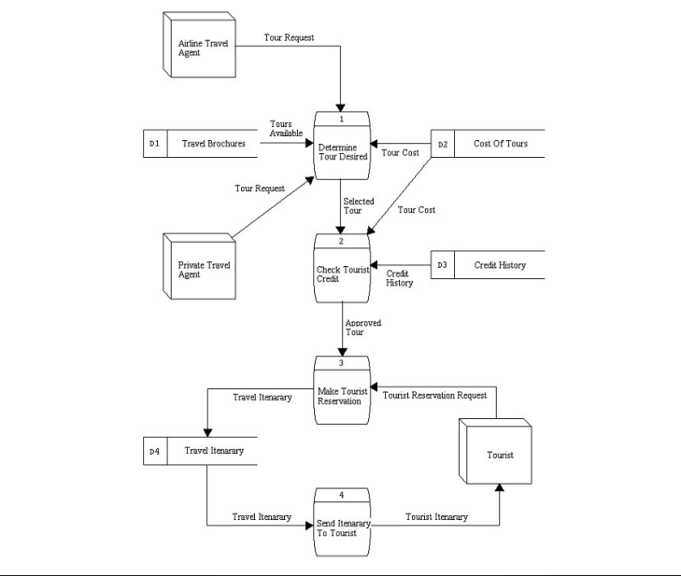

1. Use case vs data flow diagrams

**DFD**: In a business or other system, a data flow diagram shows the operations, data repositories, external entities, and linking data flows. The data flow diagram uses the following symbols:

* Open-ended Rectangles: represent data storage facilities, both electronic and physical ones. Data can be gathered for short or extended periods of time and stored in data stores.
* Squares or Ovals: represent outside sources, terminators, sinks, or sources. A terminator is typically a person or a group of individuals who are not under the control of the modelled system. It stands for the origin and destination of information. There are three crucial factors we need to keep in mind regarding terminators.
* Circles or Rounded Rectangles: represent the system's processes. It depicts a section of the system where inputs are converted into outputs. Since the process name in the symbols typically describes what it performs, it is typically used with verb-object phase. However, in other circumstances, the procedure may include a mechanical component, the name of the individual or group of individuals, or both. As a result, rather of explaining the process itself, it occasionally tells us who or what is carrying out the process.

**Use Case**: It demonstrates how a system communicates with outside parties. As a result, there are few specifics regarding how the system operates inside and how the exterior environment is set up. In fact, the use case diagram illustrates what we want the system to accomplish rather than outlining how to execute it. Communication is one of this diagram's main advantages. the main icons in use case diagrams

* Actors: are an individual, group of individuals, business, or external system that participates in one or more interactions with your system. Additionally, it could be networks, communication tools, computers, or other software running on the same machine. A stick figure is used to depict it.
* Associations: highlight the interaction that a use case has detailed. It is shown as a network of lines between actors and use cases with an optional arrowhead at one end. Take note that the arrowheads in the Use Case Diagram are intended to highlight the direction of the relationship's first invocation or to identify the main actor, whereas the arrowheads in the DFD are used to demonstrate the flow of data inside the system.
* System boundaries: is the box that contains the use cases. The functioning of the system is defined as anything inside this perimeter.

1. Anyone who wishes to examine a current condition, specify the needs for improvements, and comprehend the effects of modifying a process must master the important skill of exploding in DFD. One of the business processes to facilitate and quicken understanding, analysis, and representation is shown in this diagram below:

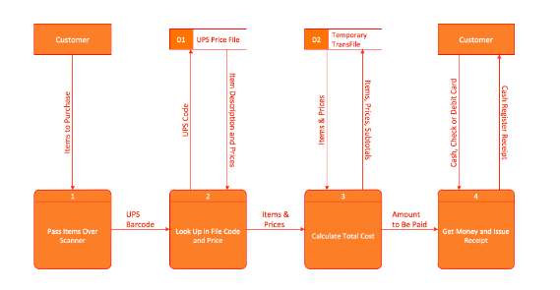

**QUESTION NUMBER: (e.g., Q2) _5_SUB-QUESTION (e.g., 2(a)) _5A, B, C_**

1. A context diagram of MTN mobile money;

Functions:

ECG,

GWSC,

SHOP,

DSTV,

BANKS

Diagram below;

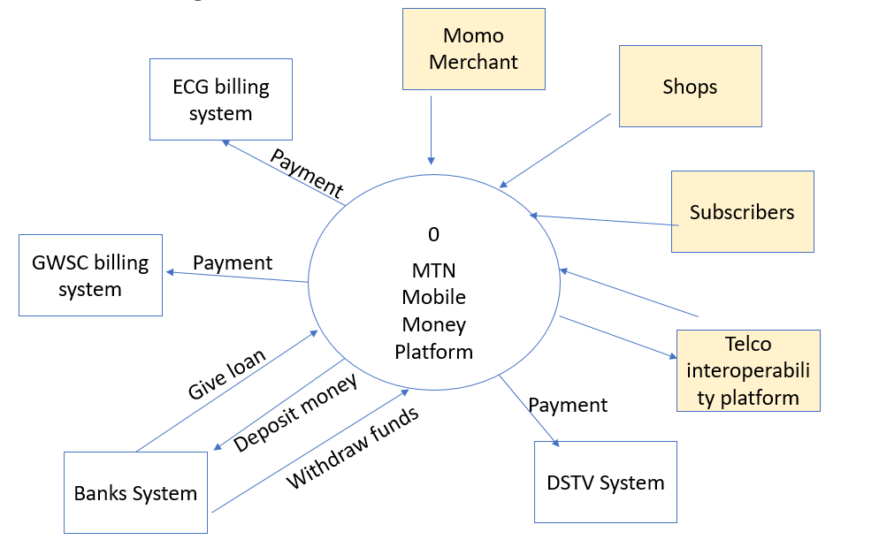

MTN MOMO CONTEXT DIAGRAM

1. Use case diagram involving subscribers only and the relevant transactions they perform:

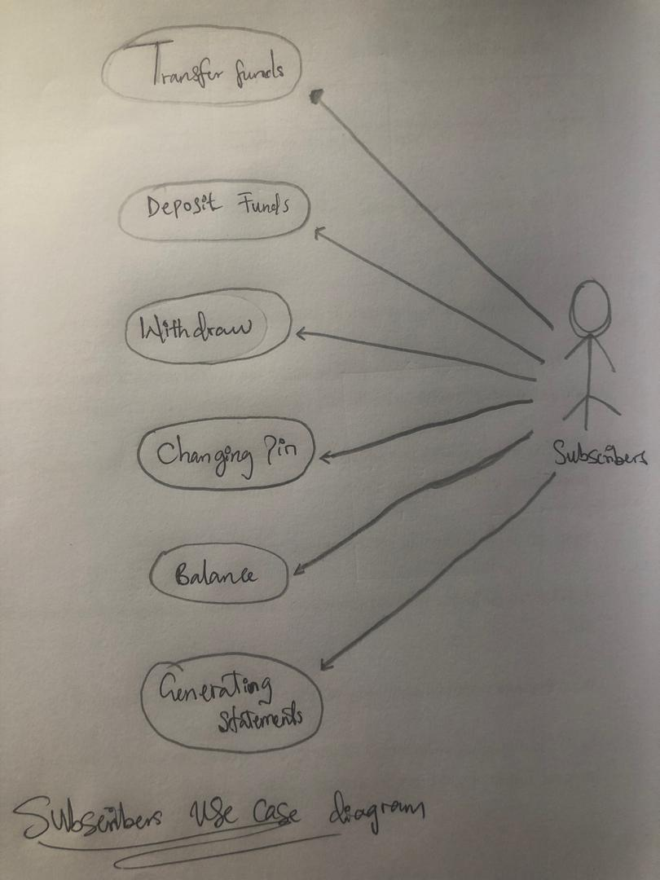

1. The importance in using a use case modeling in software analysis, design and development is that;

* Use cases help analysts define boundaries.
* Use cases can be traceable, allowing analysts to identify links between use cases and other design and documentation tools.
* Use cases effectively communicate systems requirements because the diagrams are kept simple.
* Use cases allow people to tell stories.
* Use case stories make sense to nontechnical people.
* Use cases do not depend on a special language.
* Use cases can describe most functional requirements (such as interactions between actors and applications).
* Use cases can describe nonfunctional requirements (such as performance and maintainability) through the use of stereotypes.

**QUESTION NUMBER: (e.g., Q2) _6_SUB-QUESTION (e.g., 2(a)) _6A, B, C_**

1. Class diagram of the system:

